JIRA
Demos
Document Revision History
Date | Revision No. | Author | Summary of Changes
April 2018 | 1.0 | Neelima Padmawar | New Content Creation

Table of Contents
Document Revision History 2
Demo 1. Register & Login to JIRA 4
1.1 Register to JIRA 4
1.2 Login to JIRA 5
Demo 2. Create your own Site & Project in JIRA 6
2.1 Claim your own Site & Project 6
Demo 3. Managing an Issue in JIRA 9
3.1 Create an Issue 9
3.2 Delete an Issue 11
3.3 Create a Sub task 11
Demo 4. Managing Sprints in JIRA 13
4.1 Create a Sprint 13
4.2 Start a Sprint 13
Demo 5. Generate Report 15
5.1 Generate Report 15

Demo 1. Register & Login to JIRA

Register to JIRA
Steps:
- Open Web browser i.e. I.E browser
- Launch the JIRA application using correct URL:
https://id.atlassian.com/login?application=mac&continue=https://my.atlassian.com
- Home page is displayed
- Click on ‘Sign up for an account’ and fill the required details.
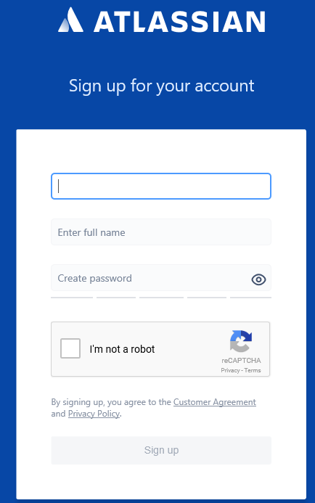

Login to JIRA
Steps:
- Once the registration is done, you can Log in.
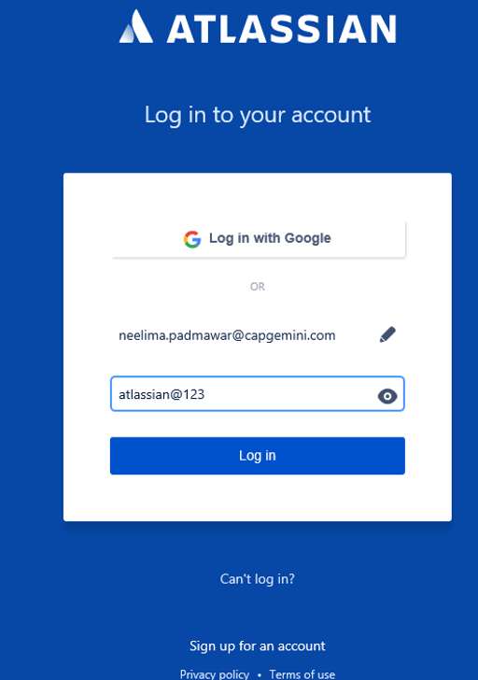
- Type valid Username and Password
- Click on Log in button
- JIRA home page will be launched successfully.

Demo 2. Create your own Site & Project in JIRA

Claim your own Site & Project
Steps :
- Click on ‘Home link once logged in. The following home page is displayed.


- Click on ‘Get started for free
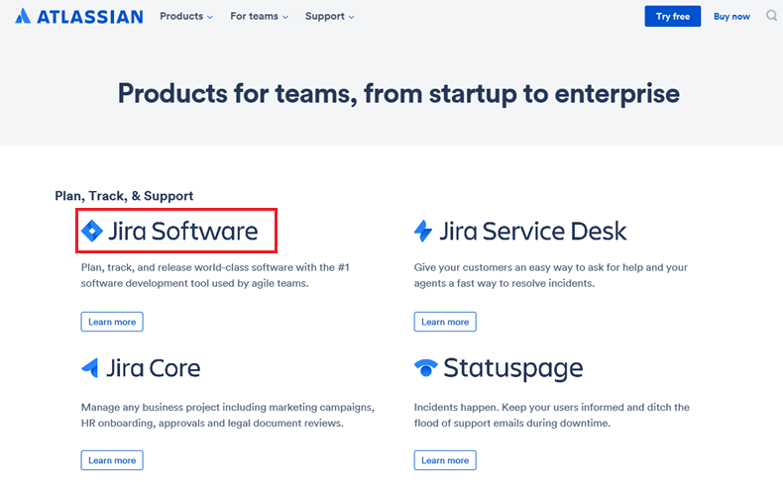
- Click on ‘Jira Software

- Click on ‘Try it free
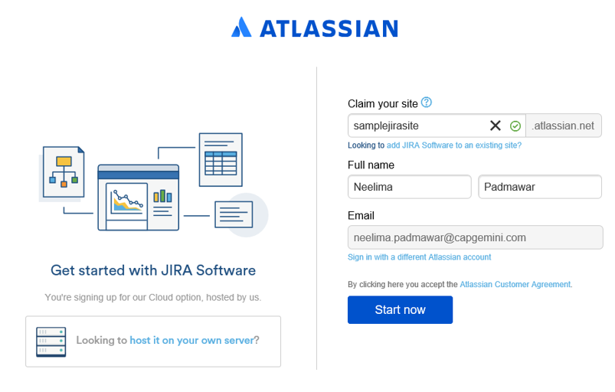
- Enter a new site name, your full name and your valid mail-id. Then click on ‘Start now.
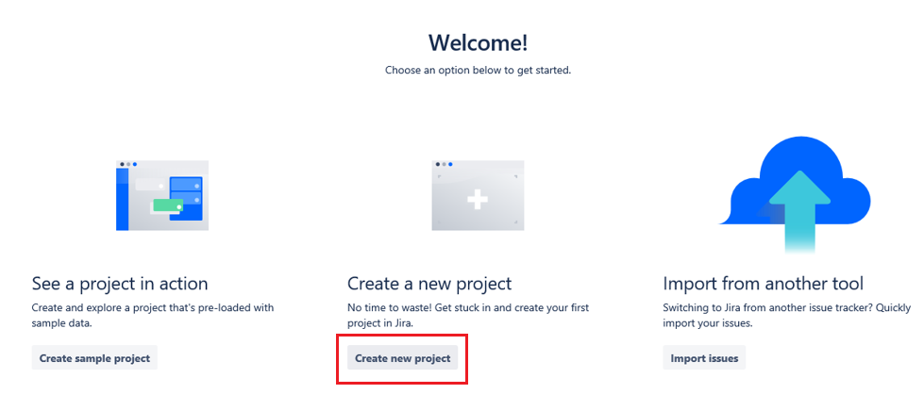
- Click on ‘Create new project
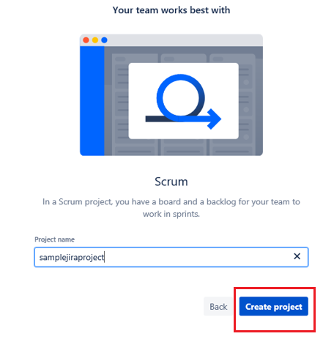
- Enter the Project name and click on ‘Create project. Your project is created now.

Demo 3. Managing an Issue in JIRA

Create an Issue
Steps:
- Once you create a project, the following main page of your project is displayed.
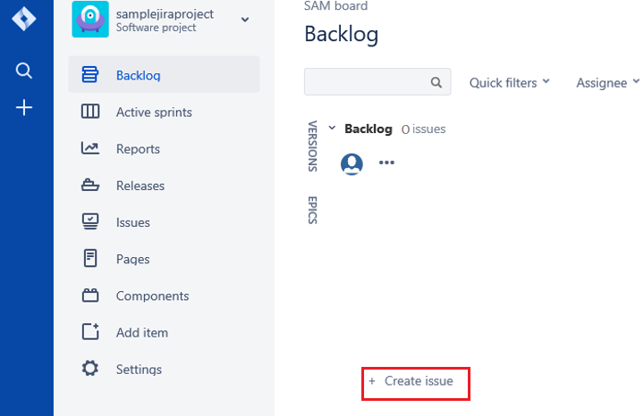
- Click on ‘Create Issue. Select Issue type ‘story / bug / task / sub-task.

- Write the issue type ‘story’ and name it as ‘There should be an option to clear the contents on the screen’ Give priority as Medium and write ‘Description’
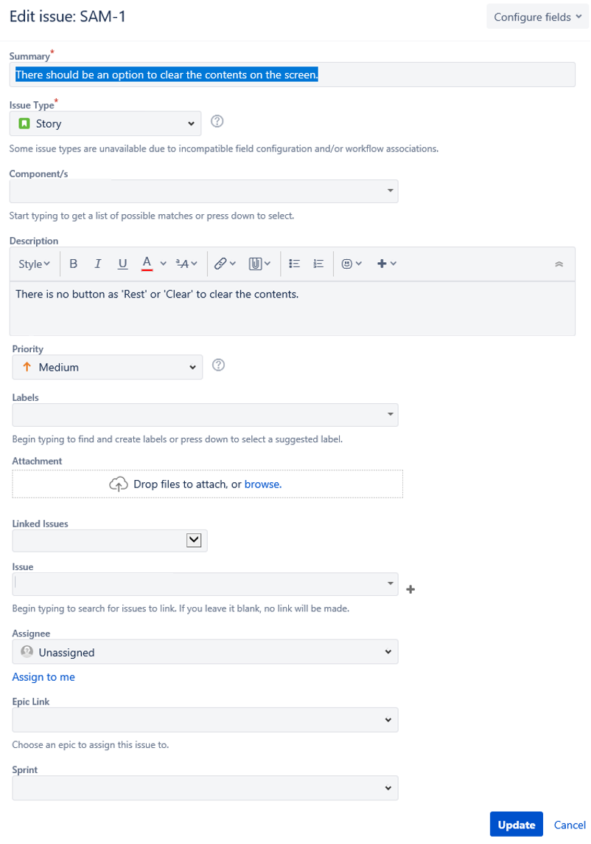

Similarly, you can create any type of issue as below ;
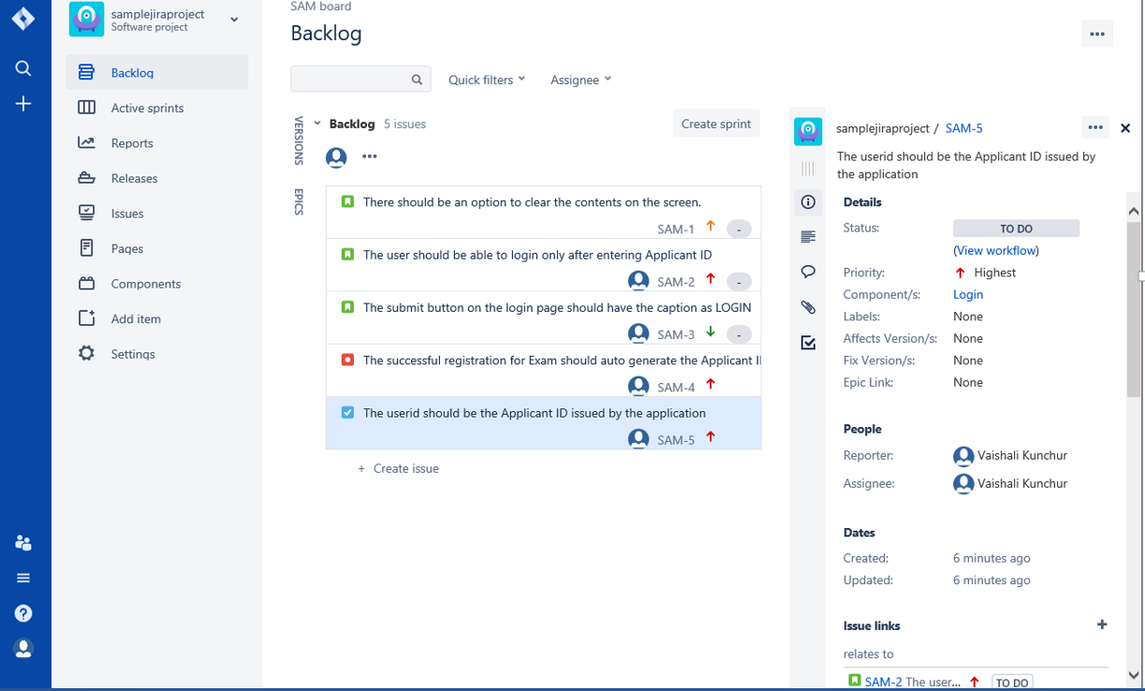

Delete an Issue
Try deleting an issue. You will not be able to do so and will get following error since the issues can only be deleted by the Administrator. (Note: We are only seeing ‘User activities)

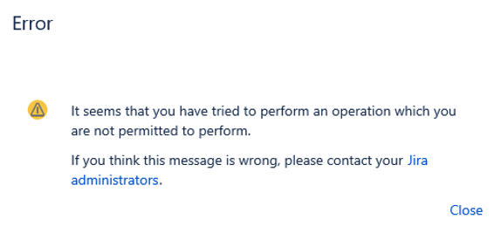

Create a Sub task
Steps:
- Select one of the issues.
- Click on the … icon.

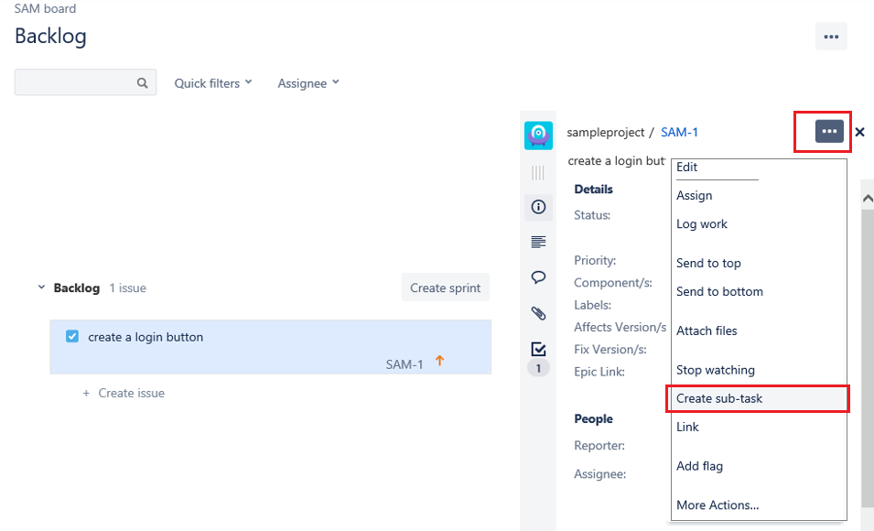
- Select ‘Create sub-task’ from the ‘Edit’ drop-down menu. The ‘Edit Issue’ window opens where you can edit the issue

Demo 4. Managing Sprints in JIRA

4.1 Create a Sprint
Steps:
Once your issues are ready, you can create multiple Sprints with a collection of issues in each sprint.
- Click on ‘Create Sprint’
- Drag drop the issues into the sprint.

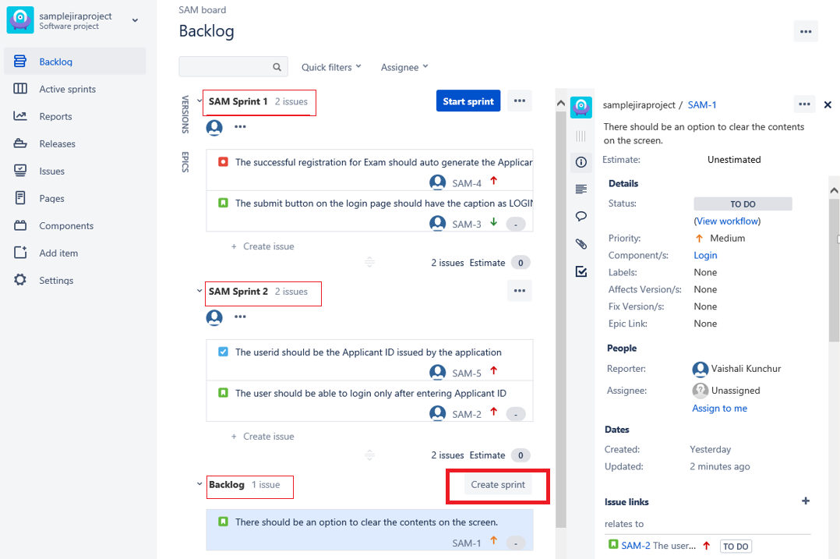

4.2 Start a Sprint
Steps:
- Click on ‘Start Sprint’
- Edit the fields in the dialog box that appears – enter the ‘start date, ‘end date & ‘Sprint goal
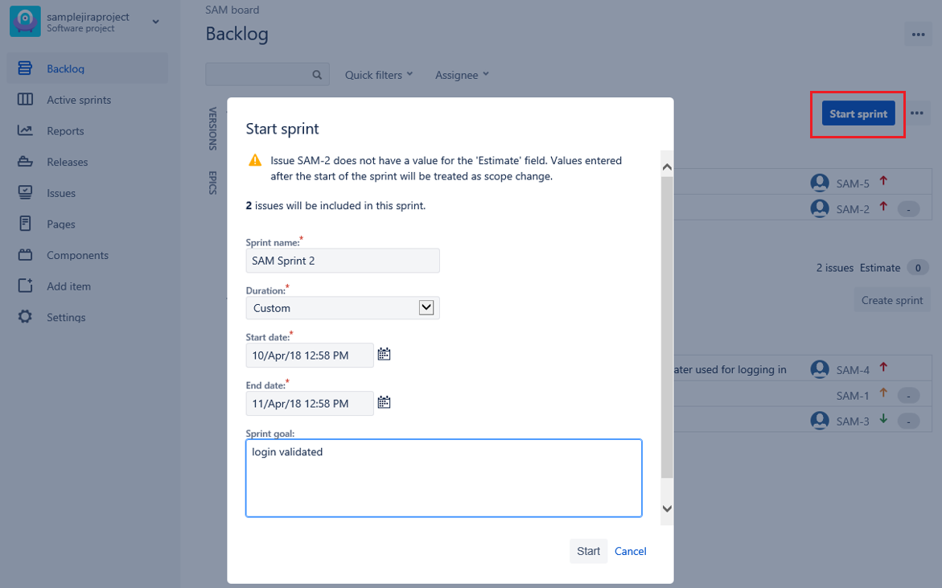
- After filling all the fields, click the button ‘Start’. You will see the following ‘Active Sprint’ page
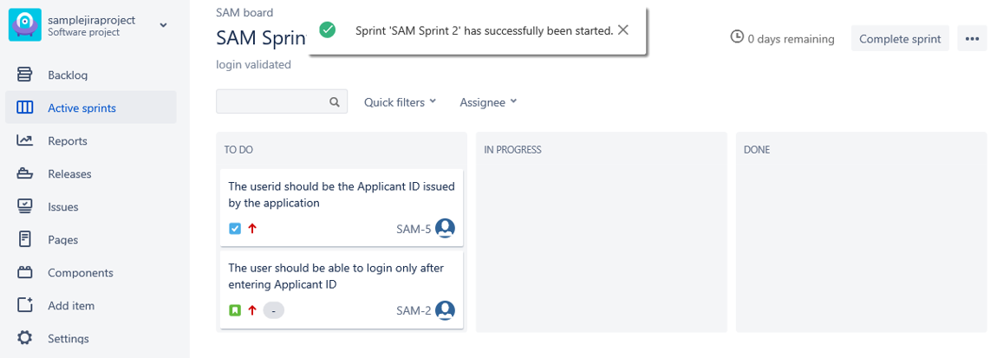

Demo 5. Generate Report

5.1 Generate Report
Following are the variety of Reports of which you can try :
- Sprint Report
- Recently Created Issue Report

